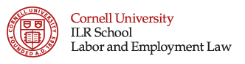 | Offered in conjunction with Cornell Law School

Sexual Orientation and Transgender Issues in the Workplace
With EEOC Commissioner Chai Feldblum

Wednesday, October 4, 2017
6:00pm – 8:00pm

AGENDA
6:00pm Welcome and Introduction
Esta R. Bigler, Director, Labor & Employment Law Program, Cornell ILR, Moderator
6:10pm Legal Issues: Sexual Orientation and Transgender Rights
Chai Feldblum, Commissioner, EEOC
Dylan Pollack, Director & Counsel at Credit Suisse Securities (USA) LLC
Martin Schmelkin, Partner, Jones Day
Micah Wissinger, Partner, Levy Ratner, P.C.
7:30pm Q&A
8:00pm Closing

Co-sponsored by:
Jones Day

