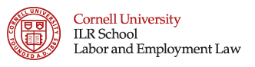 | Offered in conjunction with Cornell Law School

A Conversation with Philip A. Miscimarra, NLRB Chairman

Tuesday, June 27, 2017
6:00pm – 8:00pm

AGENDA
6:00pm Welcome and Introduction
Esta R. Bigler, Director, Labor & Employment Law Program, Cornell ILR, Moderator

6:10pm The NLRB In Transition
Philip A. Miscimarra, Chairman, NLRB
Daniel J. Ratner, Partner, Levy Ratner, P.C.
Eve I. Klein, Partner, Duane Morris LLP

7:40pm Q&A

8:00pm Closing

Co-sponsored by:
Duane Morris LLP

