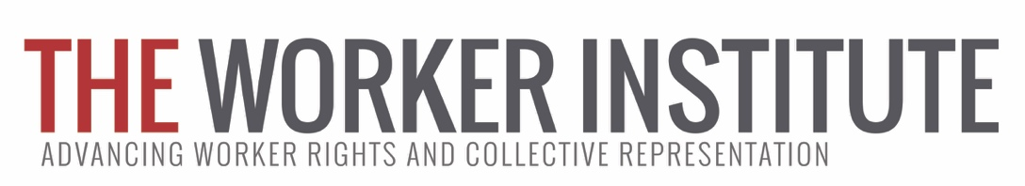

Worker Institute Summer Fellowship Program (Summer 2017)

We write to invite you to apply for a Summer Fellowship in New York City with the Worker Institute.

At its heart, the Worker Institute views its work as a contribution to reversing the growing inequality, now at historic levels, which undermines the economic and social sustainability of a vibrant democratic society. The Institute provides the nation’s most comprehensive education, training, research, and organizational support for union leaders and worker advocates. Worker Institute research fellows will have the opportunity to work directly with ILR labor extension faculty based in NYC.

The fellowship program’s goal is to provide ILR students with a unique opportunity to contribute to important projects concerning workers and unions, expand their research skills, learn about potential career paths and interact with faculty, labor leaders and other fellows.

This is a paid, full-time fellowship in NYC. Fellows will receive $3,190 in earnings this summer — they will be paid $11.00 per hour for a maximum of 290 hours of work. Project supervisors will work with each fellow to determine a timeframe.

Participants are responsible for their housing accommodations in New York City.

APPLICATION PROCEDURES: Applications are due on or before March 24, 2017.

Please fill out the attached application form and email it, along with your resume and a writing sample, to Kimberly Cook (kc948@cornell.edu) by March 24.

The main selection criteria include a strong academic record and a demonstrated interest in one of the Worker Institute’s research areas.

Award notifications for Summer 2017 fellows will be announced in April, 2017.

If you have any questions please email Kimberly Cook (kc948@cornell.edu).

FELLOWSHIP APPLICATION FORM: Due March 24, 2017

Please complete all three parts of the application and Kimberly Cook (kc948@cornell.edu) by March 24, 2017. Please also attach your resume and a writing sample.

Part I:

Name/Address/Email:

Cornell Class of:

Please indicate any languages other than English in which you are proficient:

Name and contact information of reference (ILR faculty member):

Part II: Please indicate which of the five project(s) listed below you are interested in. If you are interested in more than 1, please designate your first choice with a “1”, second choice with a “2”, and so on:

____ New York Arts and Entertainment Worker Resource Center
The Arts and Entertainment project wants a Fellow who can assist us in the research to set up a virtual resource center for younger workers in the arts and entertainment, fashion and media industries. This will involve web searches, telephone interviews, assisting in setting up and running focus groups of early-career workers, data compilation and working with the web design team. Special focus will be on developing information resources on worker rights, protections for intellectual property, and understanding the benefits of union protections in the industry. Experience with social media and information technology is required. Prior experience or affiliation with arts and entertainment organizations is preferred. (Supervisor: Sally Alvarez)

_____ Achieving Diversity in the Arts and Entertainment Industry
This project will analyze initiatives by unions, employers, government agencies, and other organizations within arts and entertainment to increase diversity within the industry’s workforce. This research will ultimately conclude with a written report analyzing best practices within the industry to increase diversity by gender, race, sexual orientation, and disability status. The fellow will be responsible for performing internet and library research, correspondence with employers and unions, and interviews with diversity program directors. Research experience involving diversity and inclusion is preferred. (Supervisor: Lois Gray)

_____ Using Technology toward Social Justice Goals
This project evaluates the use of a mobile phone application designed to prevent wage-theft and increase low-wage workers’ awareness about labor standards and workplace safety. The summer fellow will work closely with local worker centers using this application, and will assist in organizing a dialogue/conference of worker organizations currently using digital/mobile technology in labor organizing, representation, and education. Spanish language skills desirable. (Supervisor: Maria Figueroa)

______ Building a library for Education and Training Programs
The curriculum/materials/resources for our Education and Training work is not in any searchable or organized format. This summer research fellow will work to create a library of training materials – collected both from current faculty and perhaps from other outside resources. It may require reading, re-writing or formatting curriculum, and evaluating it so that it is usable both for faculty and also for clients. Interest in labor education and curriculum development required. Library science skills (e.g., how to categorize and describe materials, indexing) and technical skills with use of Google files are preferred. (Supervisor: Kimberly Cook)

______The Worker Institute at Cornell’s Labor Leading on Climate Initiative
The research fellow assigned to the Worker Institute at Cornell’s Labor Leading on Climate Initiative will conduct research, prepare concise reports, and help organize convening’s of unions and other allies related to the New York State Climate Jobs program. The Climate Jobs program is designed to enhance the role of labor and working people in addressing the climate crisis and advance policy strategies in the building, energy and transport sectors that simultaneously reduce greenhouse gas emissions, create good union jobs, and make NY communities more equitable and resilient. The Climate Jobs Fellow will research best practices in equitable climate protection and energy policy, explore financing models for investment in building efficiency, renewable energy, and public transit, and help to develop educational training curricula on climate change for members of unions and workers’ organizations. For more information, visit the NYS Climate Jobs Initiative. (Supervisor: Lara Skinner)

Part III: Please answer the following questions:

- Why are you interested in this particular project? If you have indicated interest in more than one, please provide a brief description of your interest in each (no more than one paragraph each).

- Please describe any relevant coursework, experiences, skills and abilities or anything else that you would bring to the project and make you a good candidate.

- Please describe your preferred schedule in accordance with the information provided on page 1 of the application.

