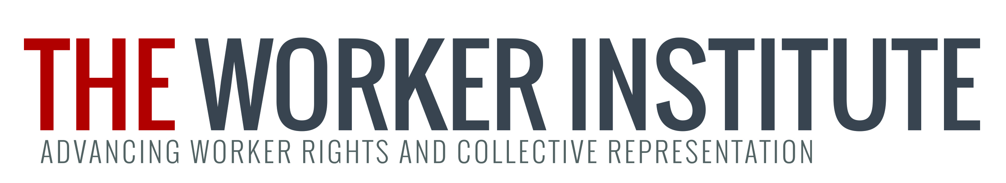

Worker Institute Summer Fellowship Program (Summer 2016)

We write to invite you to apply for a Summer Fellowship in New York City with the Worker Institute.

At its heart, the Worker Institute views its work as a contribution to reversing the growing inequality, now at historic levels, which undermines the economic and social sustainability of a vibrant democratic society. The Institute provides the nation’s most comprehensive education, training, research, and organizational support for union leaders and worker advocates. Worker Institute research fellows will have the opportunity to work directly with ILR labor extension faculty based in NYC.

The fellowship program’s goal is to provide ILR students with a unique opportunity to contribute to important projects concerning workers and unions, expand their research skills, learn about potential career paths and interact with faculty, labor leaders and other fellows.

This is a paid, full-time fellowship in NYC. The timeframe for the Summer Fellowship is May 15 to August 15, 2016. Fellows will receive $3,200 in earnings this summer — they will be paid $10.00 per hour for a maximum of 320 hours of work.

Participants are responsible for their housing accommodations in New York City.

APPLICATION PROCEDURES: Applications are due on or before April 8, 2016.

Please fill out the attached application form and email it, along with your resume and a writing sample, to Melanie Willingham-Jaggers (myw25@cornell.edu ) by April 8, 2016.

The main selection criteria include a strong academic record and a demonstrated interest in one of the Worker Institute’s research areas.

Award notifications for Summer 2016 fellows will be announced by April 22, 2016.

If you have any questions please email Melanie Willingham-Jaggers (myw25@cornell.edu).

FELLOWSHIP APPLICATION FORM: Due April 8, 2016

Please complete all three parts of the application and email it to Melanie Willingham-Jaggers (myw25@cornell.edu ) by April 8, 2016. Also, please attach your resume and a writing sample.

Part I:
Name/Address/Email:

Cornell Class of:

Please indicate any languages other than English in which you are proficient:

Name and contact information of reference (ILR faculty member):

Part II: Please indicate which of the five project(s) listed below you are interested in. If you are interested in more than 1, please designate your first choice with a “1”, second choice with a “2”, and so on:

____ Union Leadership Institute Program Evaluation Survey
The Union Leadership Institute (ULI) is a collaborative project between the New York State AFL-CIO and Cornell University. It brings together union leaders from all industry sectors and workers centers to prepare them to effectively and strategically tackle the tough challenges and new opportunities now facing workers in the new economy.
ULI will kick-start a program evaluation survey with their alumni. A summer fellow will work with the program director to reach out to alumni and encourage them to complete the web-based survey. The summer fellow will also work to gather all data generated by the survey, sort it and compile a written report of the findings.
https://www.ilr.cornell.edu/union-leadership-institute

_____ Day Laborers Research and Education Project
This project involves participatory action research on day laborers in the New York metropolitan area, in collaboration with worker centers. The project will gather and analyze data on wages and working conditions of day laborers to inform policy discussions and advocacy. In addition, this project will facilitate train-the-trainer sessions for day laborers to utilize organizing and educational tools available through mobile phone applications. Students will work in the data

Part II Continued:

collection process, assist in the training sessions and in the development of an evaluation process for the educational components of the project.
https://www.ilr.cornell.edu/worker-institute/nys-projects
.

______Labor and the Climate Crisis: A Climate Jobs Program for New York State– a policy, research and education initiative for New York unions, workers' organizations and their allies on labor-climate-employment issues, with a focus on how ambitious climate protection policy can drive job creation and economic development in New York State. The purpose of this initiative is to enhance the role of labor and working people in addressing the climate crisis. The WI Fellow will conduct research and assist with organizing a series of policy briefings on “climate jobs” in renewable energy, public transit, building energy efficiency, sustainable food and waste systems and other sectors. The Fellow will also assist with the development and dissemination of a training curriculum on climate change for workers and union members.
http://www.ilr.cornell.edu/workerinstitute/initiatives/labor-environment-and-sustainable-development.html.

______ Women as Emerging Leaders in Traditionally Male Labor Unions
To what extent are women currently making inroads in union leadership and what types of union responsibilities do they hold? How do the career patterns of women unionists compare with those of men? What can unions do to facilitate their recognition? Under the direction of Lois Spier Gray, the Jean McKelvey-Alice Grant Professor Emerita of Labor Management Relations at Cornell University's School of Industrial and Labor Relations, the WI Fellow will conduct research about women as emerging leaders in traditionally male labor unions. The summer fellow will identify emerging women leaders, interview them and write a report on the findings.
https://www.ilr.cornell.edu/people/lois-gray
http://digitalcommons.ilr.cornell.edu/cgi/viewcontent.cgi?article=1110&context=articles

Part III: Please answer the following questions:

- Why are you interested in this particular project? If you have indicated interest in more than one, please provide a brief description of your interest in each (no more than one paragraph each).

- Please describe any relevant coursework, experiences, skills and abilities or anything else that you would bring to the project and make you a good candidate.

- Will you be available to work Monday through Fridays, 9:00am to 5:00pm? If not, please describe your preferred schedule.

