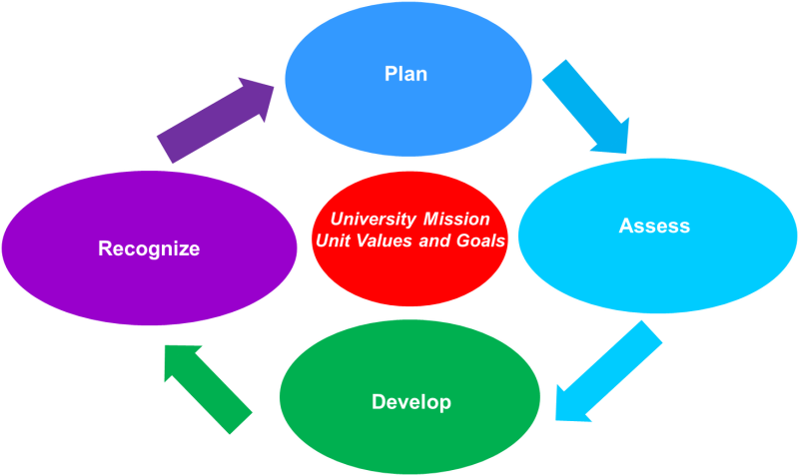
Employee Name: | Click here to enter text.
University Title: | Click here to enter text.
Unit: | Click here to enter text.
Supervisor Name: | Click here to enter text.
Review Period: | Click here to enter text.

Individual Development Plan
All employees are to complete the IDP to ensure their continuing growth and development. Supervisors are to schedule a dialogue to discuss the IDP with their employees within 30 days of an employee’s service anniversary date.

Are there strengths you would like to utilize that are not currently a part of your position description? Share specific examples.
Click here to enter text.

What are your career aspirations?
Click here to enter text.

Areas for Development
Click here to enter text.

Potential for future development
Click here to enter text.

Developmental Actions | Action Plan | Progress Report
Click here to enter text. | Click here to enter text. | Click here to enter text.
Click here to enter text. | Click here to enter text. | Click here to enter text.
Click here to enter text. | Click here to enter text. | Click here to enter text.

